Task 1: Log in to Router Admin Panel

STEPS: -
- Connect your laptop or mobile to your Wi-Fi.
- Press Windows + R, type cmd, and press Enter.
- Type: ipconfig
- Find the Default Gateway (for example, 192.168.1.1).
- Open a web browser.
- Enter the Default Gateway IP (such as http://192.168.1.1) in the address bar.
- The router login page will appear.
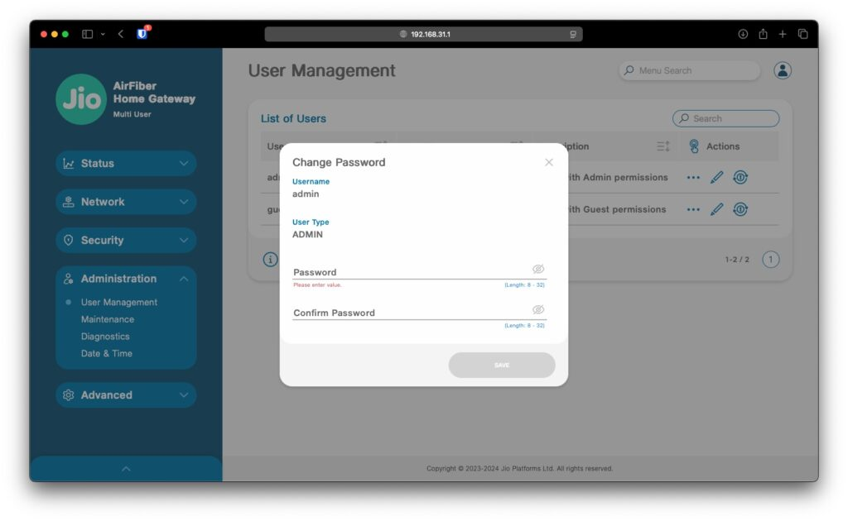
Task 2: Current Network Configuration Details

- Open Command Prompt and run ipconfig.
- Under your active connection (Wireless LAN adapter Wi-Fi), note down:
  - IPv4 Address — your device's own IP on the network (e.g., 192.168.1.23)
  - Subnet Mask — usually 255.255.255.0
  - Default Gateway — your router's IP (e.g., 192.168.1.1)
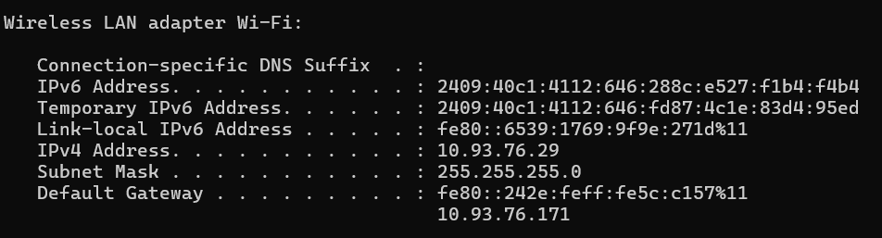
Task 3: Configure a Static IP Address

Windows Steps
- Open Settings.
- Go to Network & Internet → Wi-Fi.
- Select the connected Wi-Fi network.
- Open IP assignment → Edit.
- Change Automatic (DHCP) to Manual.
- Enable IPv4.
- Enter:
  - Router: 192.168.1.1
  - Subnet Mask: 255.255.255.0
  - Static IP: 192.168.1.50
  - Default Gateway: 192.168.1.1
  - DNS: 8.8.8.8
- Save the settings.
- Open a browser and test Internet access.
- Also test connectivity with: ping 192.168.1.1
Result
The laptop successfully uses the static IP address if it remains in the same subnet as the router and the selected address is not already being used by another device.
Important: The example address 192.168.1.50 must not be used on every network. Use an address appropriate for router's actual subnet and avoid an address already assigned to another device.

Task 4: DHCP Range & IP Conflict Analysis

- Locating the DHCP Range: Inside the router's admin web portal, navigate to Network (or Advanced) > DHCP Server.
- Recorded DHCP Scope Example:
- Start IP Address: 192.168.1.100
- End IP Address: 192.168.1.199
- Subnet Mask: 255.255.255.0

What Happens During an IP Address Conflict: If two devices are assigned the same IP address, an IP address conflict occurs. Both devices will experience unstable or completely dropped network connectivity because the router's ARP table cannot determine which physical MAC address should receive inbound data packets, resulting in continuous packet drops and an OS warning alert ("Windows has detected an IP address conflict").

